Canada-UK Postdoctoral Fellowships
for Innovation and Entrepreneurship

Frequently Asked Questions 2019

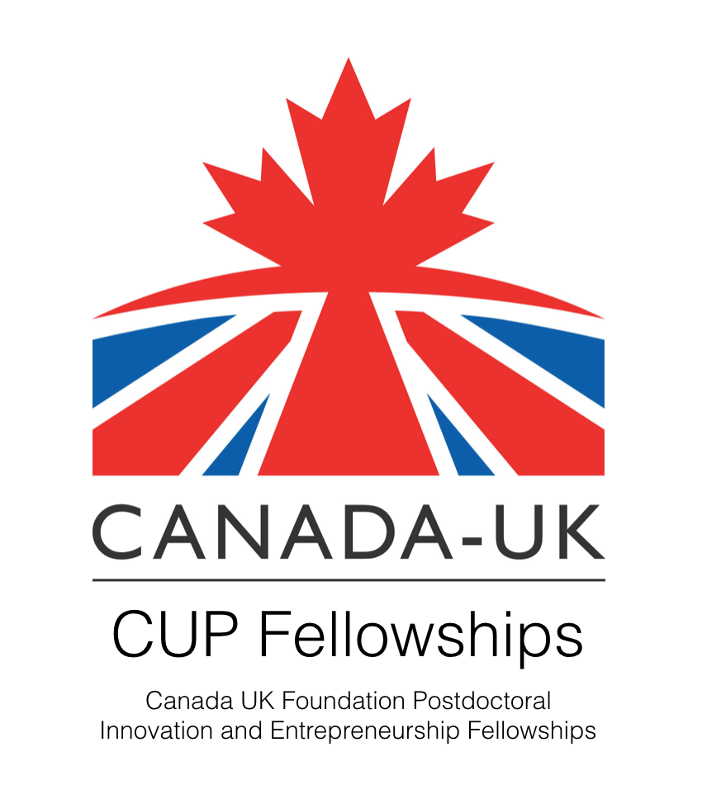

ELIGIBILITY
I have been a Postdoc for several years. Is there any post-PhD time limit on eligibility to apply for the fellowship? Is there any limit on the time of employment at Cambridge University?
There are no time limits on for how long you have been a postdoc so far or since when you have been employed by the University. The only time-relevant factor we take into account is that your contract needs to cover the whole duration of the first phase of the fellowship scheme, i.e. at least till June 2020.
However, there will be further rounds of this fellowship programme and Postdocs may want to defer their application till then; unfortunately, at present we cannot give a timetable for this.

I am not employed by the University of Cambridge, but a College or other Research Institution pays my salary. Am I eligible to apply?
Postdocs are eligible to apply for the Canada-UK Fellowship Programme if they are:
- Junior Research Fellows (JRFs); but College Teaching Officers (CTOs) are not eligible as they are salaried, permanent positions.
- Employed by a University Partner Institution (UPI).

Please get in contact if you have a query about your particular institution.

My current contract stops before June 2020 but there is a possibility that it will be extended. Am I eligible to apply for the Canada-UK Fellowship Programme?
For the first phase, the Fellowship Programme buys out a few hours of the Fellows’ research time. Therefore, it is required that applicants are employed by the University or their Partner Institutions for the whole time till June 2020.
Postdocs may still apply as long as they will have definitive information about their funding situation by 1st April 2019 and this is confirmed by their PI, line manager or Department.

There will be further rounds of this fellowship programme and Postdocs may want to defer their application till then; unfortunately, at present we cannot give a timetable for this.

I am a clinical lecturer, which is the first post-doc grade for clinicians. Can you please confirm if I am eligible to apply?
Yes, Clinical Lecturers are indeed eligible.
Please note: the salary buy-out is capped at midpoint of Grade 7 of the University salary scale.

I am a Research Associate and since one year, head of a company. Could you please let me know whether in my situation with a double role I am still eligible to apply?
Yes, you are eligible to apply.
Please note: the salary buy-out is capped at midpoint of Grade 7 of the University salary scale.

FUNDING / EMPLOYMENT STATUS
Please note that the following information is guideline only. There will be many different situations based on current employer, contract, salary spine, duration of employment etc that will be solved on a case-by-case basis.
How is the first phase of the Canada-UK Fellowship Programme funded?
The Canada-UK Fellowship buys-out 4 hrs of the Fellows’ research time during the first year of the programme; this means the department/PI saves this amount on their salary. Another 4 hrs of the Fellow’s own time is covered through a salary enhancement.
Please note: the salary buy-out is capped at midpoint of Grade 7 of the University salary scale.

What size will the salary enhancement provided with Canada-UK Fellowship Programme be?
The salary enhancement is two spine points on top of your current salary.
https://www.hr.admin.cam.ac.uk/pay-benefits/salary-scales

Can you please give further details on the independent project, particularly typical/expected costs. What expenses are covered during the independent project? What is the maximum amount of support one can request for the time?
There are no typically expected costs as each proposed project will be evaluated and approved on its own merit.
Funding for the second phase of the Canada-UK Fellowship, the independent project, will cover the full-time salary of the fellows as well as any additional reasonable expenses that are required for a successful completion of the project. The nature – travel, consumables etc - and total amount of the funding depend on the scale and timeline of the proposed project and will be considered as part of an overall funding envelope.

During the independent project, postdocs are paid full time through the fellowship. Thus, do they become University employees and have full access to University services, such as immigration support?
Yes, during the second phase normally fellows are employed through the University and thus are entitled to support from all University services.
There might be cases though where it is practical or preferable for the fellow to be paid through their home institution’ payroll, in which cases an agreement may be reached with said institutions.

Are salaries pensionable?
Yes.

APPLICATION
Who should write the Letter of Support?
The main point about the Letter of Support is to confirm that the supervisor is happy and aware that the Fellow occasionally will need to take out a day or two during the week. This letter should be provided by the person who is in a position to 'authorize' absences. Who exactly this is might be different for different applicants and could be anyone from the PI to the Departmental Head.
The letter of support should also demonstrate the applicant's suitability.
For most applicants, this letter will be come from their group leader covering all aspects, but some applicants may need to provide letters from more than one person.

Do I need to identify a mentor prior to submitting my application?
There is no need for applicants to identify a mentor themselves, as Fellows will be provided with a mentor as part of the programme.

What are the Global Challenges?
For an overview over the Global Development Goals, please see here

http://www.un.org/sustainabledevelopment/sustainable-development-goals/

What level of detail is required, in the initial application, regarding the proposed independent research project?
There is no need to refer to the independent project at this first application stage as there will be a second application after a year to bid for the independent project. However, you may refer to it if you wish.

Does a Global Challenge need to be chosen and mentioned at the first application stage?
You don’t need to refer to the Global Challenges at application though you may if you wish.

FIRST YEAR

During the first year, is the 8 hours commitment per week flexible or otherwise is there any pre-defined programme?
The first year of the fellowship is a set programme which every Fellow is required to attend. However, the programme does not take place on a weekly basis but rather in short clusters of events. There will also be working meetings of the Global Challenges ‘pods’ which will be arranged between the Fellows and individual meetings of fellows with their mentors.

Would I have to form my own ‘pod', or will there be existing ‘pods’ for each of the Global Challenges that I would then join?
The Fellows as part of the programme to come together, discuss the Global Challenges, decide on which ones to take on and set up the groups/pods. The OPdA together with the Centre for Global Equality facilitates this process and provides any support required, for example with making contacts to organisations working in the field already.
Any Fellow working on a Global Challenge as part of their current research will be asked to pick a different one (or at least a different aspect) for the purpose of the Canada-UK Fellowship Programme.

How is the final proposal for the Global Challenges project different from the independent project?
The two phases of the programme are designed to challenge the participants on different aspects:
The first year is for the fellows to work together with other fellows on a project pursuing a Global Challenge, i.e. a project outside their research interest.
The second phase of the programme is neither group- nor Global Challenges-based, but each individual Fellow would pursue a project of their own interest on their own. This project might be the Fellow’s core research interest or it might be a new project, potentially arising from the Global Challenges project.

SECOND YEAR/INDEPENDENT PROJECT

Will there be fewer places in the second year than in the first year?
Each application will be reviewed on its own merits, thus all fellows may go through to the second phase or only some. This will not affect the level of funding everybody receives.

Can you please give further details on the independent project? Are there particularly types of projects expected?
There are no typically expected project topics or formats as each proposed project will be evaluated and approved on its own merit.
The project may be academic research or any other interest of the fellow that they want to drive forward. Thus it could for example have to do with public engagement, a start-up, a piece of work for a governmental or third sector organization or similar.

Do I need to demonstrate a close relationship of the proposed independent project with my current work?
There is no requirement for Postdocs to discuss the independent project at this point of application though they can refer to it if they want. There will be a second round of application for the independent projects one year into the programme. Only at this time the actual independent project needs to be identified. These projects can – but do not need to – be connected to the Fellows’ academic area of research.

Can fellows apply to continue running an impactful project that they were involved with before the fellowship?
Yes, fellows are allowed and encouraged to continue any impactful academic or non-academic work outside the PI’s project in the second year.

You can come and meet the team administering the Fellowship scheme at any of our drop-in sessions, taking place from 12:00 – 2:00 pm, and ask more questions.
30 Jan 2019: Postdoc Centre @ Eddington, 105 Eddington Place, CB3 1AS
11 Feb 2019: Postdoc Centre @ Mill Lane, 16 Mill Lane, CB2 1SB
14 Feb 2019: Postdoc Centre @ Biomedical Campus, Clifford Allbutt Building, Hills Road, CB2 0AH
The email for any further questions is fellowships.opda@admin.cam.ac.uk

